3. Create a simple cloud software application for Property Buying & Rental process (In Chennai city) using any Cloud Service Provider to demonstrate SaaS.
Aim
To design, develop, and deploy a simple cloud-based Property Buying and Rental application for Chennai city using a Cloud Service Provider, in order to demonstrate Software as a Service (SaaS).

Procedure
- A Zoho Creator account was created and logged in using valid credentials.
- A new application named Property Buying & Rental System – Chennai City was created.
- Forms were designed to enter property details such as location in Chennai, property type, price, and rental or buying option.
- User forms were created to collect customer details and preferences.
- Workflows and validations were configured to store property and customer information securely.
- Reports were generated to display available properties for buying and rental.
- The application was deployed on the Zoho Creator cloud platform.
- The application was shared through a web URL for users to access online.

Output
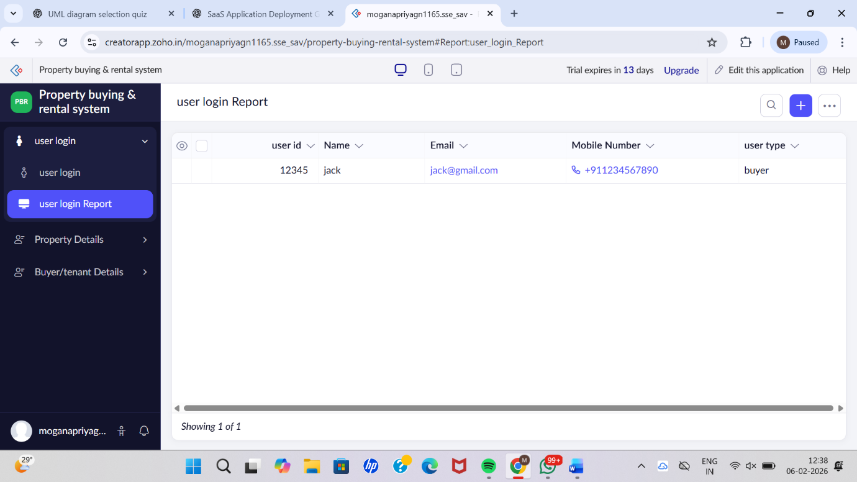

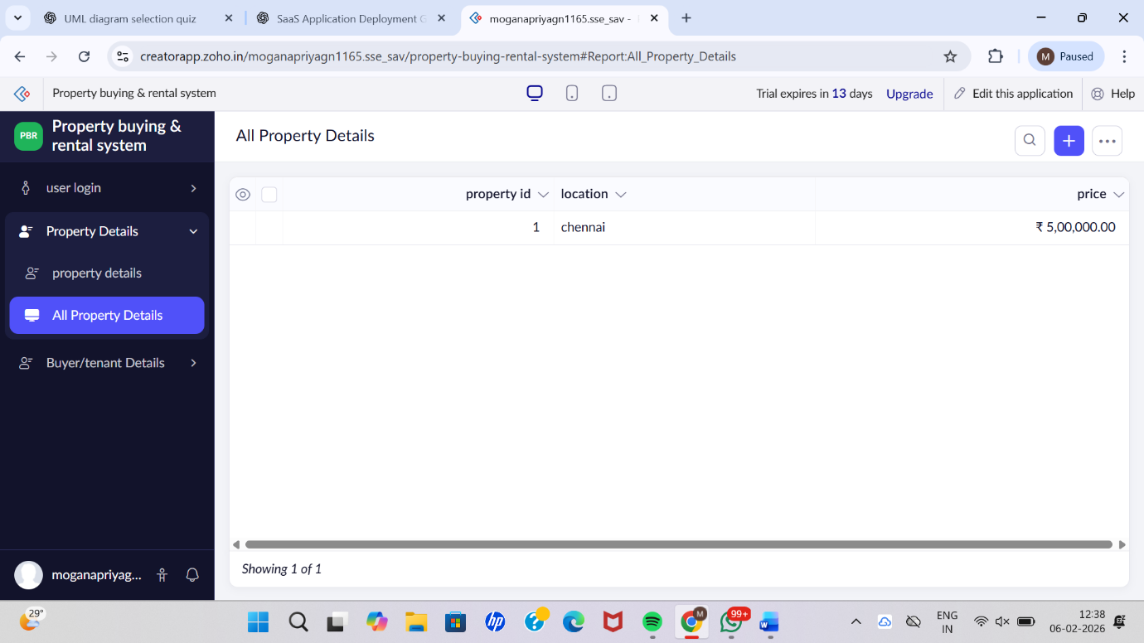

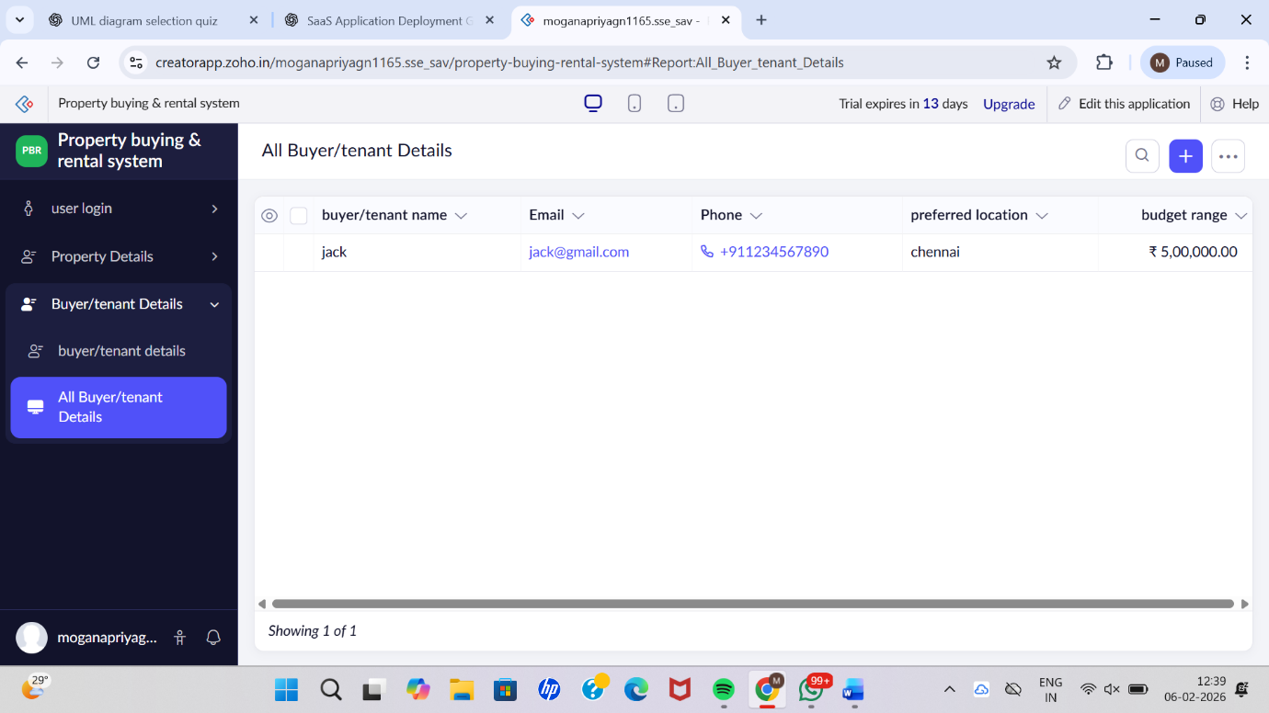

Result
Thus, a simple cloud-based Property Buying and Rental application for Chennai city was successfully created and deployed using a Cloud Service Provider. The application was delivered as Software as a Service (SaaS), allowing users to access property information and rental services online without installing any software locally.

